Major Arc
# Source: AI Source: Provided by: [Data Path: Persons Table -> ID Column: 1, Name_En Column: Motasem Essam] -> From: [ChatGPT] on [7/25/2026]
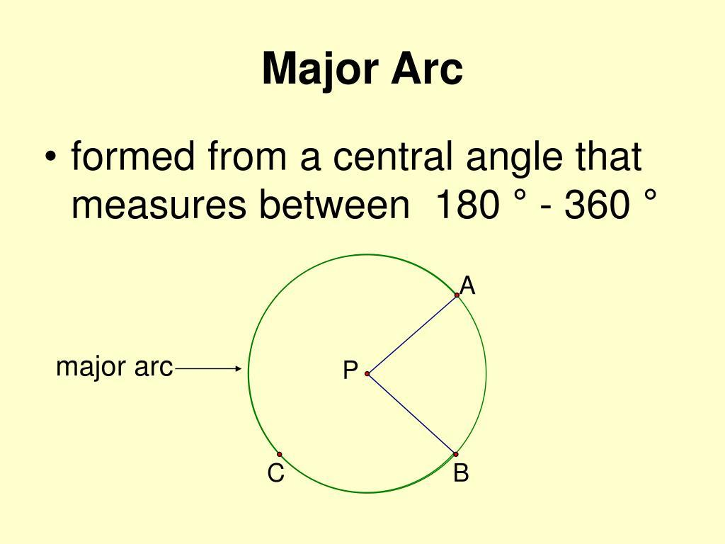
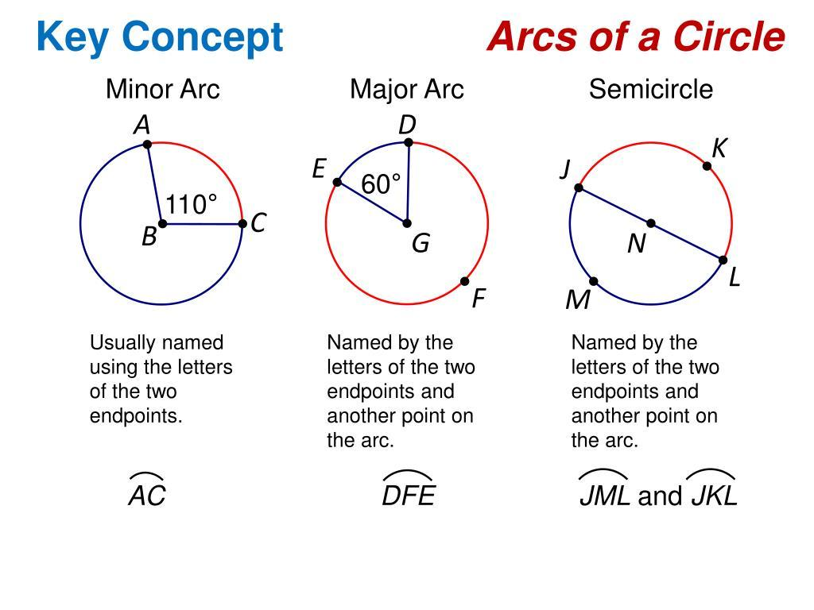
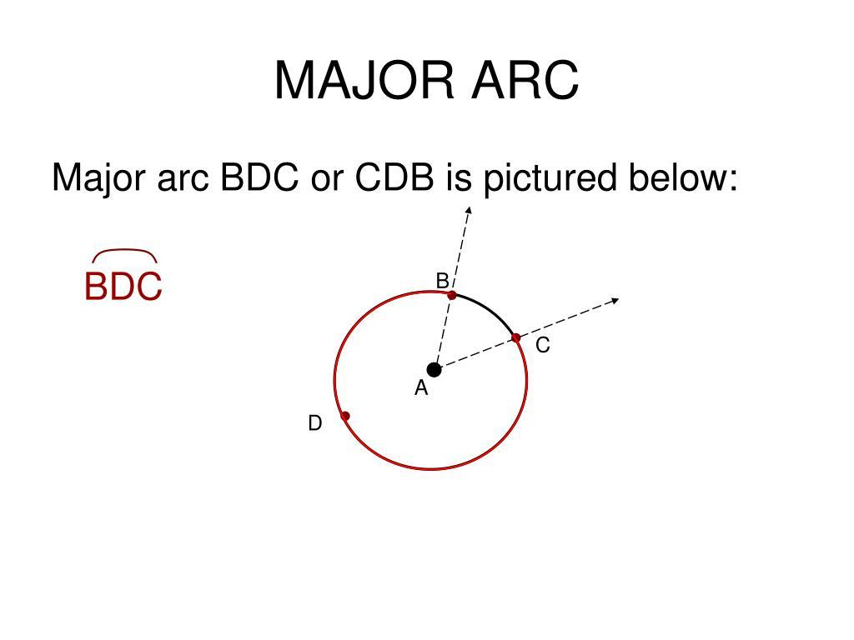
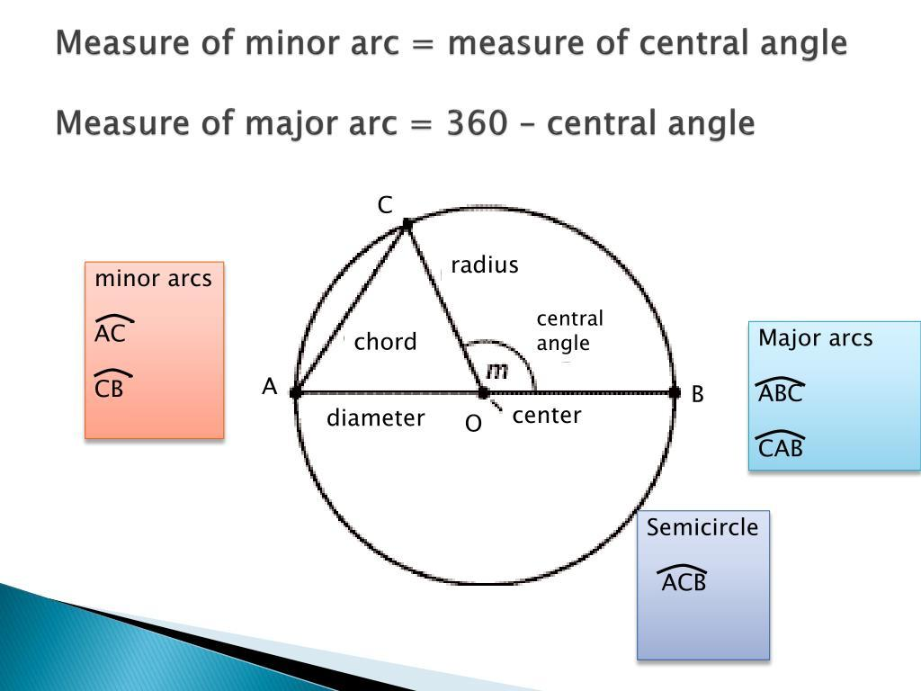
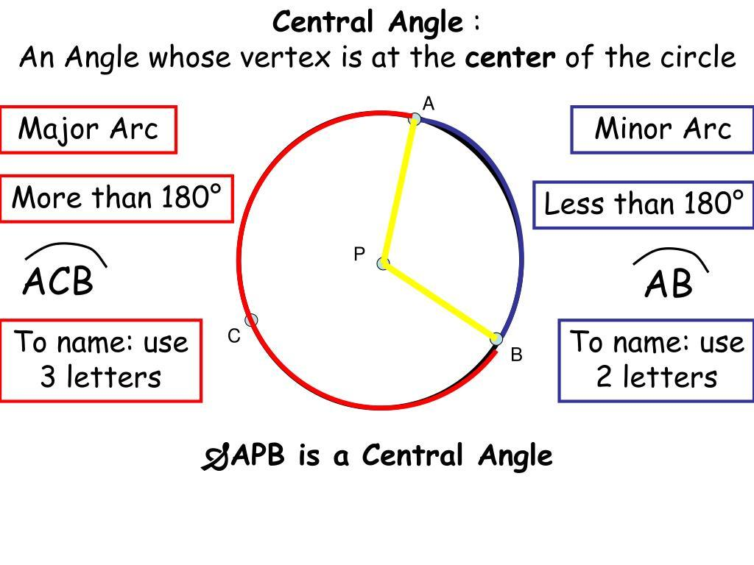
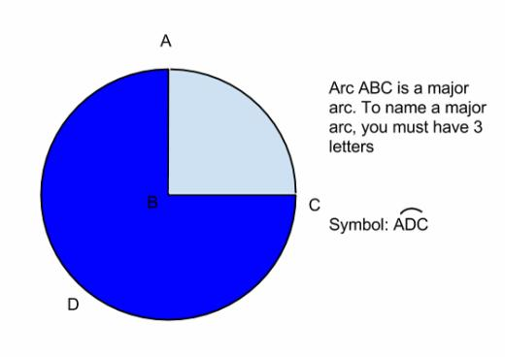

Definition
# Source: AI Source: Provided by: [Data Path: Persons Table -> ID Column: 1, Name_En Column: Motasem Essam] -> From: [ChatGPT] on [7/25/2026]
A Major Arc is an arc of a circle that measures more than ${180}^{∘}$.
It is the longer arc between two points on a circle, when those points are not endpoints of a diameter.
If $A$and $B$are two points on a circle, the major arc from $A$to $B$is commonly identified using three letters, such as:
$$\hat{ACB}$$
where $C$lies on the major arc between $A$and $B$.

Fundamental Concept
# Source: AI Source: Provided by: [Data Path: Persons Table -> ID Column: 1, Name_En Column: Motasem Essam] -> From: [ChatGPT] on [7/25/2026]
Two distinct points on a circle divide the circumference into two arcs:
- A minor arc — less than ${180}^{∘}$
- A major arc — greater than ${180}^{∘}$
Their measures add to one complete circle:
$$m\left(\text{Minor Arc}\right)+m\left(\text{Major Arc}\right)={360}^{∘}$$
Therefore:
$$\boxed{m\left(\text{Major Arc}\right)={360}^{∘}-m\left(\text{Minor Arc}\right)}$$

Fundamental Elements
# Source: AI Source: Provided by: [Data Path: Persons Table -> ID Column: 1, Name_En Column: Motasem Essam] -> From: [ChatGPT] on [7/25/2026]
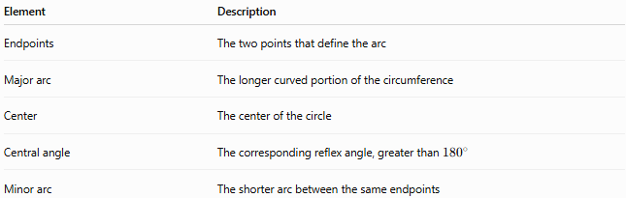
Element | Description
Endpoints | The two points that define the arc
Major arc | The longer curved portion of the circumference
Center | The center of the circle
Central angle | The corresponding reflex angle, greater than ${180}^{∘}$
Minor arc | The shorter arc between the same endpoints

Mathematical Representation
# Source: AI Source: Provided by: [Data Path: Persons Table -> ID Column: 1, Name_En Column: Motasem Essam] -> From: [ChatGPT] on [7/25/2026]
For a major arc:
$$\boxed{{180}^{∘}<m\left(\hat{AB}\right)<{360}^{∘}}$$
Its corresponding reflex central angle satisfies:
$${180}^{∘}<θ<{360}^{∘}$$
The arc measure and its corresponding central angle are equal:
$$m\left(\hat{AB}\right)=m\left(∠AOB\right)$$
when $∠AOB$is taken as the reflex central angle.

Arc Length
# Source: AI Source: Provided by: [Data Path: Persons Table -> ID Column: 1, Name_En Column: Motasem Essam] -> From: [ChatGPT] on [7/25/2026]
If the radius is $r$and the major arc has measure $θ$degrees:
$$\boxed{L=\frac{θ}{{360}^{∘}}\left(2πr\right)}$$
Since:
$${180}^{∘}<θ<{360}^{∘}$$
the major arc is longer than a semicircular arc but shorter than the complete circumference.
In radians:
$$\boxed{L=rθ}$$
where:
$$π<θ<2π$$

Example
# Source: AI Source: Provided by: [Data Path: Persons Table -> ID Column: 1, Name_En Column: Motasem Essam] -> From: [ChatGPT] on [7/25/2026]
Suppose a circle has radius:
$$r=10\text{ cm}$$
and the minor arc between $A$and $B$measures:
$${80}^{∘}$$
Then the corresponding major arc measures:
$${360}^{∘}-{80}^{∘}={280}^{∘}$$
Because:
$${280}^{∘}>{180}^{∘}$$
it is a major arc.
Its length is:
$$L=\frac{{280}^{∘}}{{360}^{∘}}\left(2π⋅10\right) \\ L=\frac{140π}{9}\text{ cm} \\ L≈48.87\text{ cm}$$

Major Arc and Minor Arc
# Source: AI Source: Provided by: [Data Path: Persons Table -> ID Column: 1, Name_En Column: Motasem Essam] -> From: [ChatGPT] on [7/25/2026]
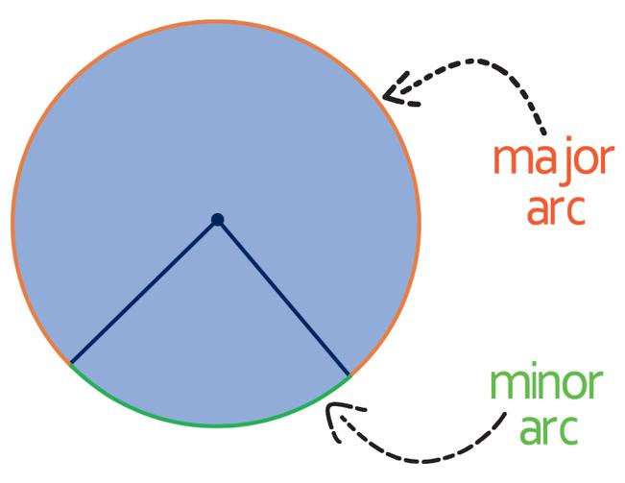
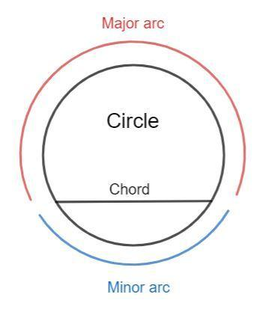
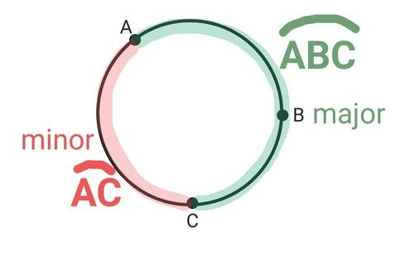
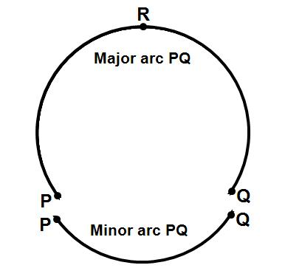
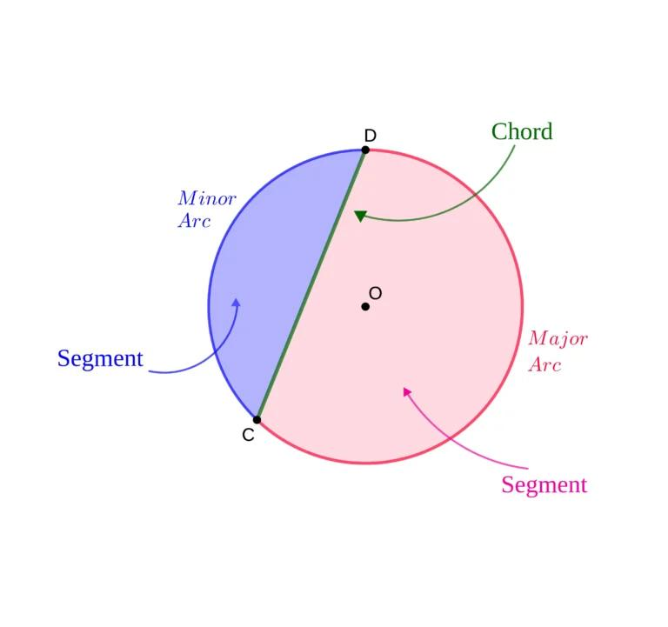
The same two endpoints can define both a minor arc and a major arc.
For example:
$$m\left(\hat{AB}\right)={100}^{∘}$$
for the minor arc.
Then the major arc is:
$${360}^{∘}-{100}^{∘}={260}^{∘}$$
Thus:
$${100}^{∘}+{260}^{∘}={360}^{∘}$$

Major Arc and Semicircular Arc
# Source: AI Source: Provided by: [Data Path: Persons Table -> ID Column: 1, Name_En Column: Motasem Essam] -> From: [ChatGPT] on [7/25/2026]
A major arc is not a semicircular arc.
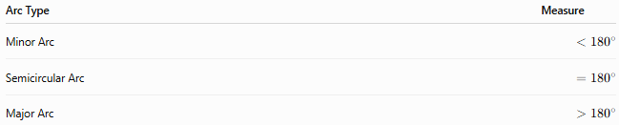
Arc Type | Measure
Minor Arc | $$<{180}^{∘}$$
Semicircular Arc | $$={180}^{∘}$$
Major Arc | $$>{180}^{∘}$$
The distinction is based entirely on the arc's measure.

Naming a Major Arc
# Source: AI Source: Provided by: [Data Path: Persons Table -> ID Column: 1, Name_En Column: Motasem Essam] -> From: [ChatGPT] on [7/25/2026]
Because the same two endpoints can identify two different arcs, a major arc is usually named using three letters.
For example:
$$\hat{ACB}$$
means the arc from $A$to $B$passing through $C$.
If $C$lies on the longer route between $A$and $B$, then $\hat{ACB}$represents the major arc.
Using only:
$$\hat{AB}$$
can be ambiguous when both arcs need to be distinguished.

Major Arc and Chord
# Source: AI Source: Provided by: [Data Path: Persons Table -> ID Column: 1, Name_En Column: Motasem Essam] -> From: [ChatGPT] on [7/25/2026]
The major arc and its corresponding chord have the same two endpoints but are fundamentally different geometric objects:
- Major arc → curved portion of the circumference.
- Chord → straight line segment connecting the endpoints.
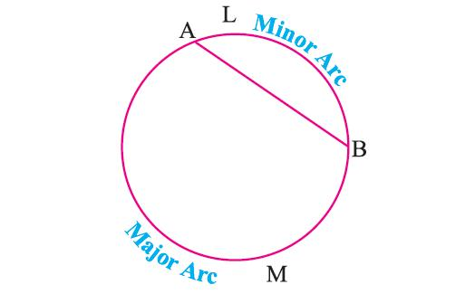
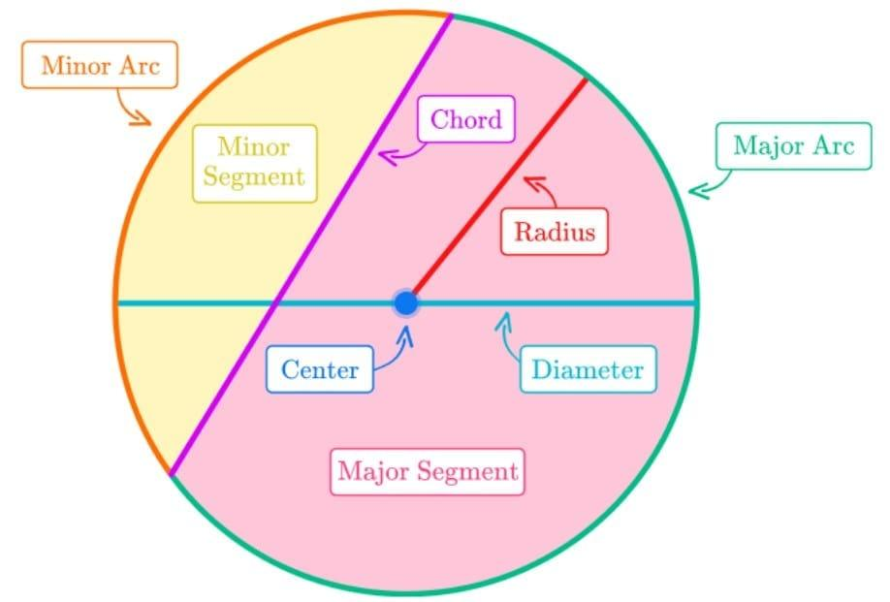
The chord corresponding to a major arc is still the same chord connecting the two endpoints.

Major Arc and Inscribed Angle
# Source: AI Source: Provided by: [Data Path: Persons Table -> ID Column: 1, Name_En Column: Motasem Essam] -> From: [ChatGPT] on [7/25/2026]
An inscribed angle that intercepts a major arc has a measure equal to half the measure of that major arc:
$$m\left(∠ACB\right)=\frac{1}{2}m\left(\hat{AB}\right)$$
For example, if:
$$m\left(\hat{AB}\right)={240}^{∘}$$
then:
$$m\left(∠ACB\right)={120}^{∘}$$
The intercepted arc must be the arc opposite the vertex of the inscribed angle.

Main Properties
# Source: AI Source: Provided by: [Data Path: Persons Table -> ID Column: 1, Name_En Column: Motasem Essam] -> From: [ChatGPT] on [7/25/2026]
- A major arc measures more than ${180}^{∘}$.
- It is the longer arc between two points on a circle.
- Its endpoints are the same as those of the corresponding minor arc.
- Its corresponding central angle is a reflex angle.
- Its arc length is greater than half the circumference.
- Its arc length is less than the full circumference.
- A major arc and its corresponding minor arc together form the complete circumference.
- Three-letter notation is commonly used to distinguish a major arc from the minor arc with the same endpoints.

Classification
# Source: AI Source: Provided by: [Data Path: Persons Table -> ID Column: 1, Name_En Column: Motasem Essam] -> From: [ChatGPT] on [7/25/2026]
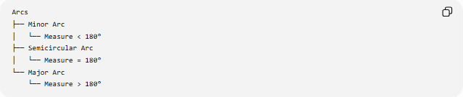
Arcs
├── Minor Arc
│ └── Measure < 180°
├── Semicircular Arc
│ └── Measure = 180°
└── Major Arc
└── Measure > 180°

Relationship with Circle Parts
# Source: AI Source: Provided by: [Data Path: Persons Table -> ID Column: 1, Name_En Column: Motasem Essam] -> From: [ChatGPT] on [7/25/2026]
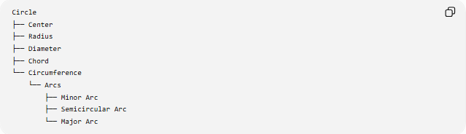
Circle
├── Center
├── Radius
├── Diameter
├── Chord
└── Circumference
└── Arcs
├── Minor Arc
├── Semicircular Arc
└── Major Arc

Key Points
# Source: AI Source: Provided by: [Data Path: Persons Table -> ID Column: 1, Name_En Column: Motasem Essam] -> From: [ChatGPT] on [7/25/2026]
- Major Arc = longer arc between two points on a circle.
- Its measure satisfies:
$$\boxed{{180}^{∘}<m\left(\text{Major Arc}\right)<{360}^{∘}}$$
- Its length is greater than $πr$.
- The corresponding minor and major arcs have a total measure of ${360}^{∘}$.
- Three-letter notation is commonly used for a major arc.
- A major arc is a curved portion of the circumference, not a chord or a region.

Conclusion
# Source: AI Source: Provided by: [Data Path: Persons Table -> ID Column: 1, Name_En Column: Motasem Essam] -> From: [ChatGPT] on [7/25/2026]
A Major Arc is the portion of a circle's circumference measuring more than ${180}^{∘}$. It is the longer of the two arcs determined by two non-diameter points and is commonly named with three letters to distinguish it from the corresponding minor arc. Its measure, central angle, and arc length provide the main ways to describe and calculate it.

